# DES 335

**Spring-2025**

**Week 12: Playtest Notes/P4 Influential NPCS**

**DigiPen Institute of Technology**

## Student Name: Matthew Oliver

## Game System: Warring Worlds

## Goal

This report has two sections. Their goals are described below.

## Character Creation (Advanced) Playtest Notes Requirements

Playtesting is critical for any game development. During lab, you will be placed into groups to discuss, analyze, and playtest each other’s character creation rules. Each member of the group should attempt to make an “advanced” character, utilizing your rules as written. This report documents your observations, notes, and actionable items that come from that playtesting.

You are required to do at least ONE (1) playtest session of around 30 minutes per person. However, you are highly encouraged to do additional playtesting. If you do, use as many of the Optional Playtest Notes sections below as needed.

## Influential NPCs Report Requirements

* Write up THREE (3) influential, powerful, or plot-twisting NPCs that you intend to include in your RPG's world setting--one must be beneficial to the world, one neutral (but still influential), and one antagonistic/villain.
* Write up a physical description, short backstory, personality traits and quirks, their primary motivation/challenges and their role in society and/or impact on your world.
* Provide THREE (3) plot hooks for how the NPC can interact with the PCs.
* Include the NPC's full statistics using your RPG system
* Include a picture that roughly corresponds to each NPCs (include URL or accreditation on where the image was found).

## NOTE: Integrate, Don’t Cut and Paste

You can utilize this information into your P4 working document. DO NOT merely cut-and-paste what you write into your draft and be done with it—it will still require editing, massaging, and formatting to integrate.

## Rubric

This, like other weekly reports, is not considered a separate grade, but affects your overall final grade.

* **-2%:** Not Submitted at time of grading
* **-1%:** Insufficient information, missing categories; Late turnover of assignment (Instructor discretion)
* **+0%:** Sufficient information and interesting NPC with decent plot hooks
* **+1%:** Very interesting NPC, intriguing motivations, and clever plot hooks

This page does not count towards total page count; start on next page.

## Playtest Session #1 [REQUIRED]

**Date:** 4/6

**Location:** Over discord

**Number of Playtesters:** 2

**Duration:** 15min

**Playtest Summary**

**The good**

Both playtesters were able to get through character creation fairly quickly, it did not take them forever to do. One playtester read through the rules more carefully and was able to create a character with only one error, which will need to be fixed. The other one struggled to find certain things simply because he did not read through the rules as carefully, however to prevent this in the future I will consider reformatting to make things flow more smoothly and easier to find.

**The bad**

Both playtesters struggled once or twice to find certain things. One of them could not figure out how to determine his starting health, but this was mostly due to skimming the rules without actually reading them. The other had a few struggles but was able to figure them out on his own without any prompting.

**The ugly**

Both players completely missed one thing on their characters, with each one missing something different. One missed the attribute increase from his species, the other the equipment he gained from his background. Things gained from backgrounds and species need to be made much more clear as right now there is not really an explanation.

**Playtest Notes**

Both using chapter 4

One choosing magic

Not doing species bonuses

Doing attributes and skills correctly

Realizes species bonus later

More money than intended

One struggling to find their health

“Gonna guess I don’t need arrows”

Didn’t read species

Found what Acuity does

“Acuity is charisma”

Looks at background again and fails to notice equipment

Spent wrong currency

Struggled to find health

Had to be prompted for background equipment

Other did it way out of order

Never got attribute bonus, had to be prompted

# NPC #1— Elder Forgom

## Role: Beneficial to the World

## Picture

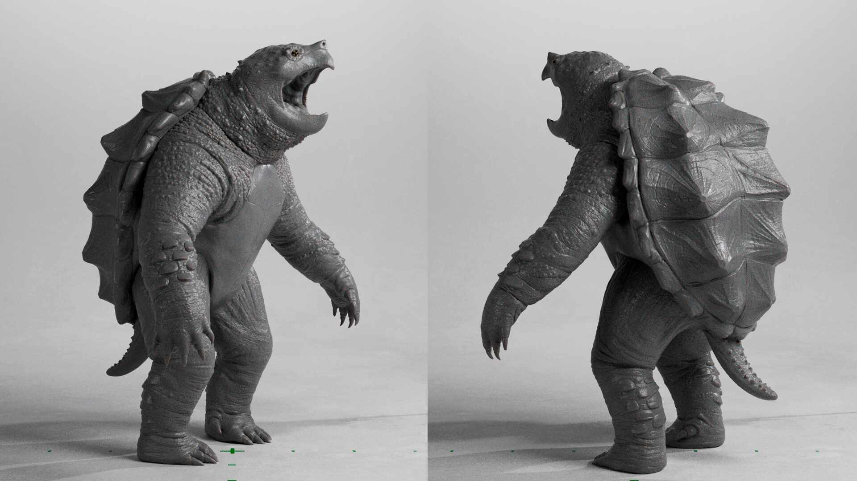

<https://www.zbrushcentral.com/uploads/default/original/4X/c/8/0/c80c27000c1911250ff0267aad8bf080dc3fad30.jpeg>

## Overview

Elder Forgom is the leader of the Amphibian Tribe which resides in the Eastern Swamp. Elder Forgom was the first World Child leader to initiate friendly relations with Humans. He responded positively to requests for trade and to the formation of the Adventurer’s Guild. As such, friendly relations with Humans became more widespread and tensions around Sylvara have eased. Since then Forgom has continued to advocate for friendly relations between World Children and Humans and has become a well-known figure in this movement.

## History

Forgom wasn’t always the Elder of the Amphibian Tribe. He was born 59 years ago to unimportant parents. Over the course of his childhood he watched as his people suffered at the hands of famine, disease, and monster attacks. All of these disasters were made worse by the fact that his tribe had taken in several of the refugee World Children species. This inflated the population of the Amphibian Tribe and stretched their already thin resources. But Forgom never blamed them, he understood that it was not their fault. Nor did he blame the Humans, whose blame could be argued.

Once Forgom became an adult he decided to seek out ways to improve the lives of his tribemates. He ventured into nearby Lands, inhabited by other World Children groups. In those lands he spoke of his tribe’s plight, and asked if there was any way that they could help. After speaking for some time Forgom realized that there were things that this land lacked which his had in abundance and vice versa. So Forgom proposed a trade deal, meant to make everyone’s lives easier. Upon returning home he was met with roaring approval, his deals with the other World Children had been a massive success and his people’s lives had improved a drastic amount.

From then on Forgom became an important figure in his tribe and the surrounding lands. His wisdom at such a young age impressed many and, over the course of the next few decades, Forgom continued to improve the lives of all the World Children in the region. Once Forgom became old enough, he was elected Elder and there he has stayed for another several decades.

## Personality & Quirks

Forgom is described by most to be a “funny old turtle.” He has a strange sense of humor and seems to make light of even the most grave situations. Yet his wisdom is unmatched. It is said that there has never been a question that Forgom could not answer, though it may take him several weeks to do so. Forgom is friendly and welcoming to all, inviting anyone and everyone into his home. In his old age Forgom has found use in a walking cane to help him get around. However, it seems that he still has all the energy of his youth as he often takes strides which are far too big and jams his cane into his foot.

## Motivations, Goals, and Challenges

Forgom’s primary motivation is just that he wants to see everyone happy. He does not have fond memories of his youth, when death was a constant companion for his people. As such Forgom has continued to pursue peaceful, beneficial relations with everyone that he can. He not only wants to help his tribe, he wants to help everyone prosper. Forgom is a proponent of open trade between the various World Child and Human groups, often saying that everyone has something that someone else needs. Unfortunately, there is still a lot of push back from both Human and World Children. Hard times make hard people, and it will take a lot of convincing to get some groups to open up.

## Physical Description

Elder Forgom is an Akchi, or snapping turtle person. His scales are cracked and yellowed from age, and it is clear that his shell is weighing him down far more than it used to. Forgom wears simple garb and the only item that he typically carries with him is his cane, which he needs for walking. His shell is a deep, deep green, with plenty of blemishes that he earned during the adventures of his youth.

## Plot Hooks

* **Hook 1: Forgom wants someone to speak with the Confederated Ape Tribe to see if they will open their borders, he has chosen the players.**
* **Hook 2: A dangerous monster is attacking the Amphibian Tribe and Forgom has put in a request at the nearest Adventurer’s Guild, which was taken by the players.**
* **Hook 3: The Amphibian Tribe is experiencing a shortage of healing herbs, and Forgom has put out a request for some.**

## Game Statistics

**Hit Points – 45**

**Attributes – S(3), D(1), C(2), I(2), A(3), W(3)**

**Skills – Athletics(3), Critical Thinking (4), Social Skills (3)**

**Languages – Sylvar, Amphib, Foresti, Outworld**

**Movement – 25ft. Walk speed, 30ft. Swim speed**

**Traits - Shell**

# NPC #2— Bracker

## Role: Neutral / Self-Interested

## Picture

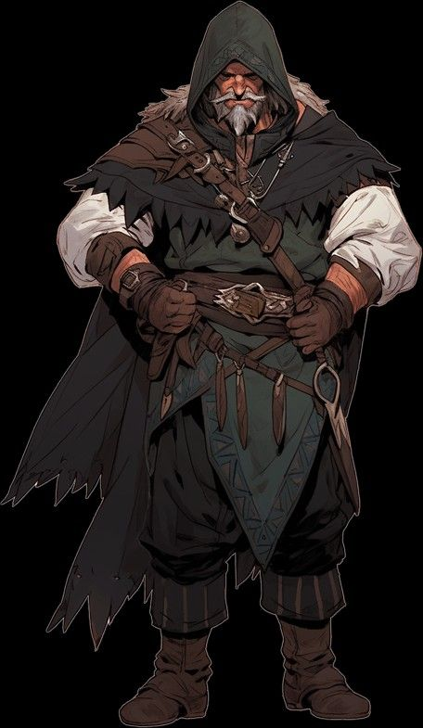

<https://i.pinimg.com/736x/82/67/83/826783fa1cbaf28c83351328710d8f07.jpg>

## Overview

Bracker is the current leader of the first Adventurer’s Guild. This puts him as a very important position as the head of the world’s first neutral institution. Bracker’s job is essentially to ensure that every group, Human or World Child, receives equal attention from the guild. Part of doing this is making sure that Quests are regularly received from every settlement and group in the region. These Quests are what ensure that monster attacks or herb shortages don’t assail the various peoples.

## History

Bracker used to make his living as a wandering monster hunter. He would travel from settlement to settlement, slaying any monsters that were bothering the local people. Word of his exploits spread around the region, and he eventually caught the attention of a Human King from a nearby Nation. This king told him that he wanted to form a new institution, one which would be completely neutral between Humans and World Children. This new entity, the Adventurer’s Guild, would benefit all people by allowing them to make requests and having qualified people come and handle them. He wanted Bracker to be the leader of this new organization.

Bracker did not want to give up his freedom, which he valued over everything else. But could not help but see the potential in the king’s plan. So, he agreed. Bracker started the Adventurer’s Guild 20 years ago, and since then it has has grown into a global organization, with Guildhalls all over Sylvara. Bracker has continued to lead the organization and has earned a legendary reputation.

## Personality & Quirks

Bracker is a frank, straightforward man. He tends to struggle in the negotiations he’s forced to attend due to his general lack of social skills. He isn’t capable of performing the kinds of verbal sparring that others would request of him. Instead he gets right to the point, skipping past any extra considerations or other “useless junk.” Bracker is extremely bored with his job, sneaking out as often as he can to go hunt monsters. Many times has someone come to his office for something important, only to discover his window open and a note on his desk that reads “Gone hunting.”

## Motivations, Goals, and Challenges

Bracker may be bored with his job, but he would never quit it. Bracker saw first hand how the World Children were suffering and understands how important it is to keep up the kind of progress that he has championed for the last two decades. Over the years he has butted heads with many stubborn people that didn’t want to work with others, preferring to stay isolated in their lands. Many of these meetings ended in brawls or shouting matches, frustrating Bracker to no end. But he always comes back, he keeps pestering people over and over until they see the wisdom of his words. Bracker wants to see all of the guilds grow, not just his own. He wants peaceful relations and prosperous times to become the norm, rather than the exception.

## Physical Description

Bracker is a human of about 60. He has short, speckled black hair with a matching short goatee. He is typically seen wearing his favorite hide armor and wielding a long sword. Bracker is a veteran adventurer, and as such knows that a successful adventurer is always prepared. When he is leaving to go somewhere Bracker has a massive pack and several pouches that he’ll wear which carry almost anything he could ever need.

## Plot Hooks

* **Hook 1: Bracker has put out a special quest and the players have decided to accept it**
* **Hook 2: The players catch Bracker sneaking out of his office and he takes them hunting to keep them quiet**
* **Hook 3: The players get into a fight in the Guildhall and Bracker comes out to see what the fuss is about.**

## Game Statistics

**Hit Points – 79**

**Attributes – S(4), D(1), C(3), I(2), A(2), W(2)**

**Skills – Athletics(3), Brawn(4), Aggression(3), Weapon Mastery(4)**

**Languages – Outworld, Sylvar**

**Movement – 45ft. Walk speed**

# NPC #3— Ssithari

## Role: Antagonistic/Villain

## Picture

<https://i.pinimg.com/736x/b5/ba/0c/b5ba0c478683f56624a2b692d0be1aac.jpg>

## Overview

Ssithari is the current Dragon Priest of the Cold-Blood Empire, which is bent on violent and rapid expansion. Ssithari has ordered increasingly frequent raids on neighboring lands and has also raised the number of captives fed to the Dragon Spirit. Under Ssithari the Empire has increased it military might by a great deal and now stands poised to initiate a full scale invasion of the neighboring lands. This threat has people all over the world scared and represents what is probably the current biggest calamity facing Sylvara.

## History

Ssithari is the eldest child of the previous Dragon Priest Ssithan. As is expected of the eldest in the Dragon Priest line she fought, and then ate, all of the other siblings in her clutch. Throughout her childhood she was indoctrinated and taught all of the various horrible beliefs and practices of her people. She watched every day as dozens of people were fed to the Dragon Spirit, hissing in glee at the sounds of his approval. She proved a quick and especially sadistic study, killing her father and taking over his position before even reaching maturity.

Since taking her father’s title she has dedicated herself to continuing the Empire’s path towards domination. Ordering for more and more slaves to be taken and forced to work for the Empire’s benefit. Now the day finally draws near when the preparations will be complete and the Empire will be ready to expand.

## Personality & Quirks

Ssithari was raised from birth to be a sadistic zealot, finding joy in watching the Dragon Spirit devour hundreds of slaves every day. Despite this, she is actually a very effective and merciful leader. She treats her subordinates fairly and does not punish honest mistakes. She is soft-spoken at all times but when publicly speaking, at which point she shows herself to be a fantastic orator.

## Motivations, Goals, and Challenges

Ssithari’s goal is the same as all of her predecessors, expand the Empire’s influence so that more and more captives can be sacrificed to the Dragon Spirit. Like all people of the Empire, Ssithari worships the Dragon Spirit and is proud and happy to offer sacrifices to him. The people of the Empire view this Dragon Spirit to be a physical manifestation of the World Spirit, and so a direct connection to Sylvara itself. Ssithari is dedicated to seeing the Empire expand through conquest.

## Physical Description

Ssithari is an Uruma, or anaconda person. Uruma do not have legs like most species and instead balance on their tail. Ssithari is an albino, which is not as uncommon in Uruma as other species. Her scales are snow white and her eyes blood red, giving her a striking appearance. She wears only her religious garbs, which consist of blood red robes with white trim. She carries nothing else on her as anything she needs can be easily brought to her.

## Plot Hooks

<Come up with THREE (3) Plot Hooks (1-2 sentences each) about the NPC that would involve the PCs and/or draw them into the NPC’s attention and orbit.>

* **Hook 1: The players have been tasked with defending a village from an Empire raid**
* **Hook 2: The players have been captured in a raid and need to escape**
* **Hook 3: The players have been asked to scout out the Empire to see how far their military preparations have progressed.**

## Game Statistics

**Hit Points – 34**

**Attributes – S(1), D(3), C(2), I(4), A(4), W(2)**

**Skills – Social Skills (4)**

**Languages – Sylvar, Hiss-Speech**

**Movement – 60ft. Walk speed**